PROJECT REPORT
Design and Development of Three Websites

CASE 01  Whimsybell Bakery | CASE 02  Crave Kitchen
CASE 03  Unlockd Real Estate | TECHNOLOGIES  HTML and CSS

Submitted by: Syed Haadiya Fathima
Roll Number: 26000059
Branch / Section: CSE-1

This report describes the purpose, major sections, design choices and visible outputs of the three submitted website projects. The bakery's order page is included as a supporting page of the bakery website.

Introduction
The project contains three front-end website designs built with HTML for page structure and CSS for presentation and layout. Each website uses its own visual theme and content to suit a different purpose: displaying bakery products, presenting a restaurant menu, and browsing real-estate properties.

Objectives
- Create clear, attractive and easy-to-navigate website pages.
- Organize content into sections using headings, images, cards and navigation links.
- Apply CSS colours, spacing, typography, grids and hover effects to improve presentation.
- Include responsive layout rules where provided in the source files.

Tools and Technologies
HTML: structures the content, links, images, navigation and input controls.
CSS: controls colours, fonts, alignment, card layouts, spacing, responsive breakpoints and hover effects.
Note: The output panels in this report are clean illustrative previews of the main page areas, based on the uploaded HTML/CSS files. They are not captured browser screenshots.

Case No. 09

Whimsybell Bakery Website

Explanation
A bakery showcase website that introduces Whimsybell Bakery and presents cakes, pastries and other sweet items to visitors.

Main Features
- Navigation links for Home, Menu, Custom Cakes, Gallery and Contact.
- A hero section with the heading “Sweet Moments” and a call-to-action to explore the menu.
- A product collection showing item names, descriptions and prices, including cakes, cookies, cupcakes, donuts and pie tarts.
- A custom-cake feature, seasonal offer, image gallery and contact details.
- A separate order page (order.html) for customer details, item selection, quantity, preferred date, pickup or delivery, address and special instructions.

Design and Implementation
Uses a soft pink, cream and brown palette, rounded product cards, bakery imagery, serif headings and hover effects. CSS media queries rearrange product and gallery layouts for smaller screens.

Output
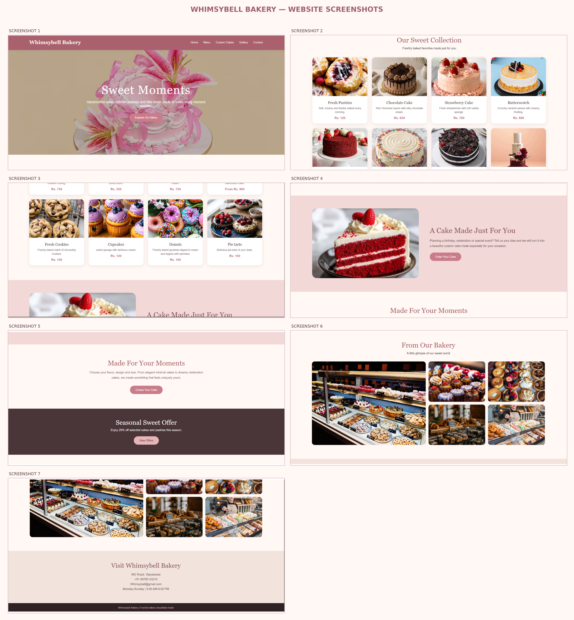
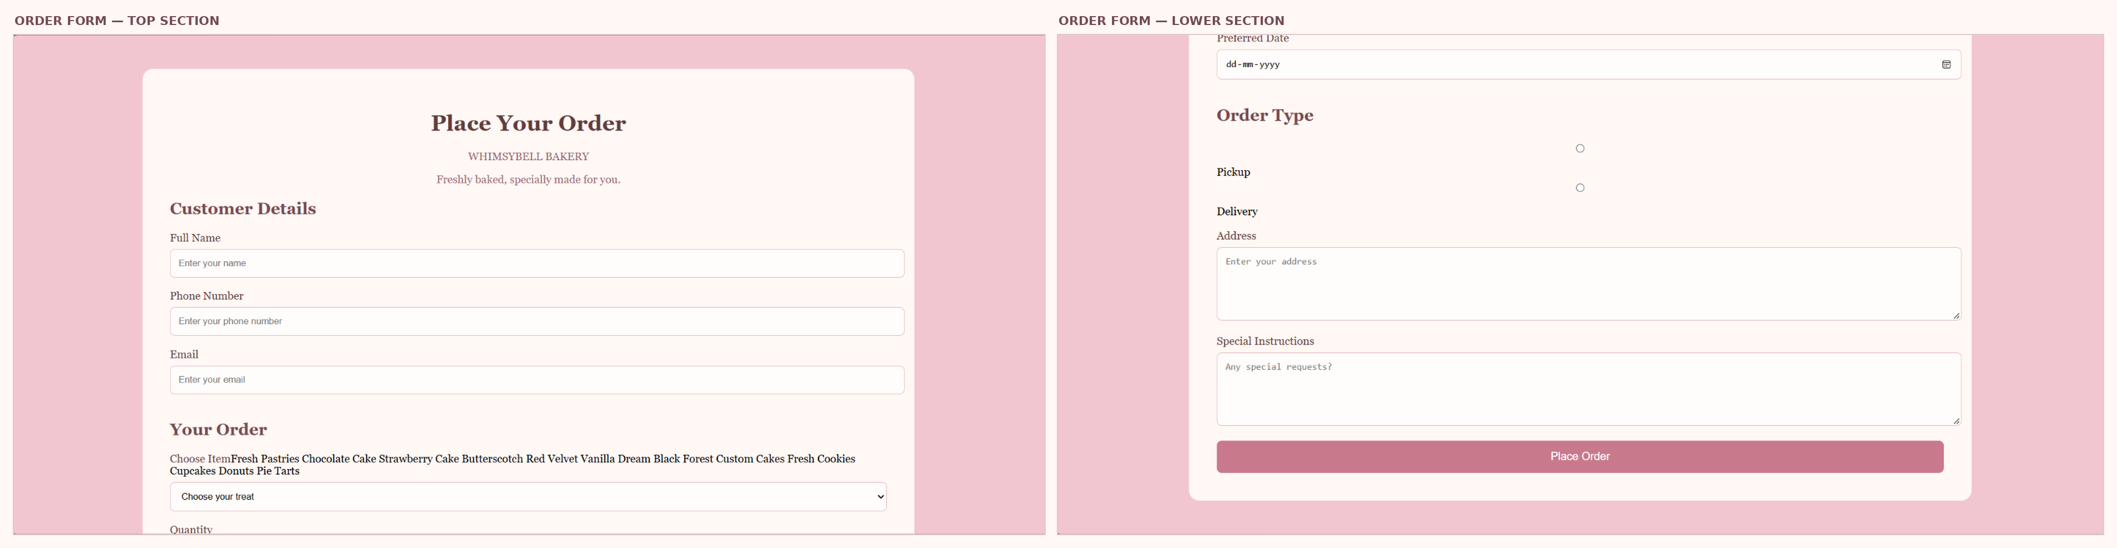

Case No. 20

Crave Kitchen Restaurant Website

Explanation
A restaurant website designed to introduce Crave Kitchen, highlight signature food items and display the menu in clear categories.

Main Features
- Top navigation for About, Special, Menu, Orders and Gallery.
- A hero area with the message “Good Food. Great Mood.” and a link to explore the menu.
- A restaurant introduction and signature-food cards for burgers, wood-fired pizza and chef’s specials.
- Menu categories including dishes, desserts, ice creams, starters and soups, with descriptions and prices.
- Order links, a restaurant gallery, contact information and opening-hours section.

Design and Implementation
Uses dark charcoal, deep green, cream, red and gold accents to create a warm restaurant identity. CSS grid layouts organize food cards, while hover effects add movement to menu items.

Output
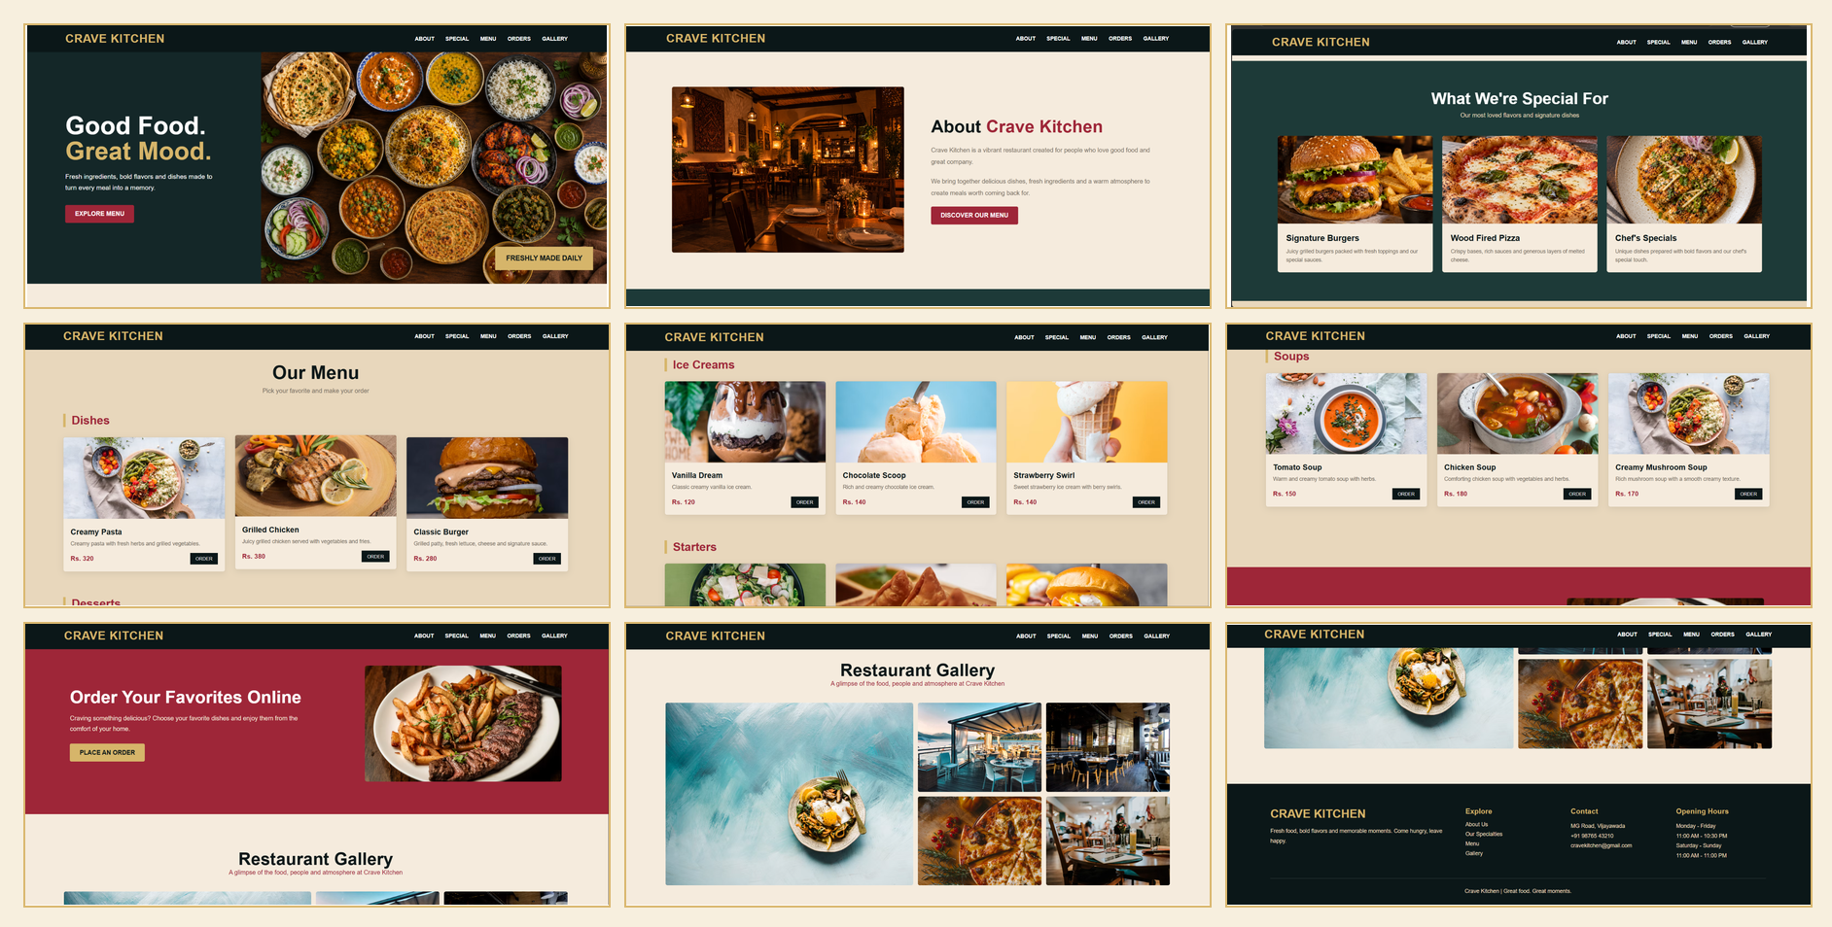

Case No. 10

Unlockd Real Estate Website

Explanation
A real-estate showcase website that helps visitors explore property types and compare selected property details.

Main Features
- A modern hero section with the message “Beautiful spaces. Better living.”
- A search panel with selection controls for narrowing property preferences.
- Featured property cards with property names, locations, prices and feature summaries.
- Property categories such as modern houses, apartments, luxury villas and rental homes.
- An amenities section, property comparison table and call-to-action section.

Design and Implementation
Uses teal, coral, pale blue and off-white with modern typography and large property images. Cards use hover effects, and CSS grid layouts arrange properties and categories. Responsive styling adjusts layouts for narrower screens.

Output
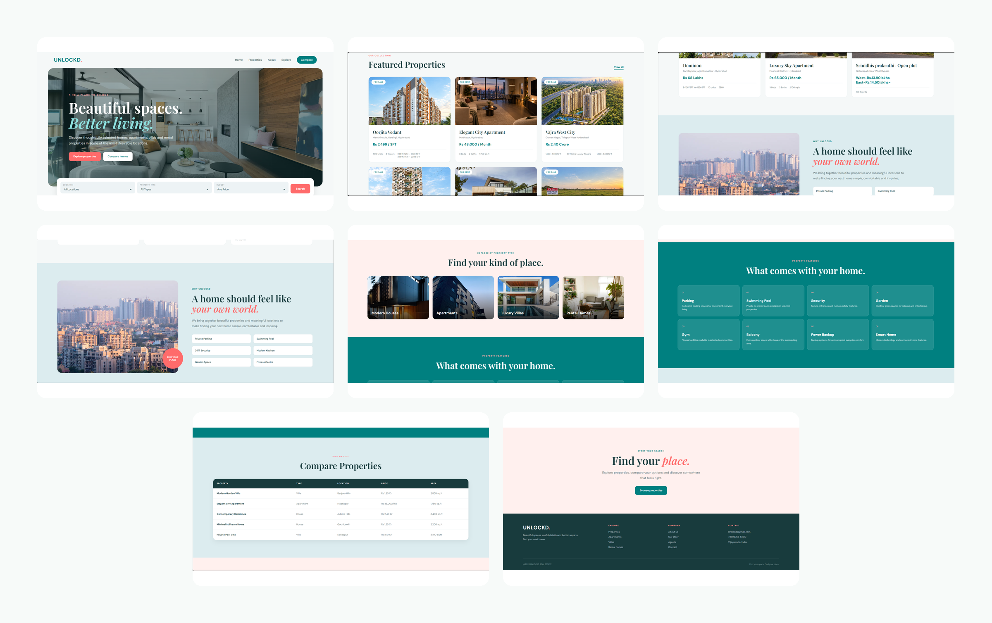

Conclusion
The three projects demonstrate how HTML and CSS can be used to create different types of websites with distinct visual identities and purposes. Whimsybell Bakery focuses on bakery products and ordering, Crave Kitchen presents restaurant dishes and menu sections, and Unlockd helps visitors explore real-estate options. Together, the projects demonstrate page structure, styling, content organization and responsive design concepts.

